*Contents*

Document Versioning 1

**1** Key concept 2

**2** Author 2

**3** Brief bio about the author 2

**4** Business Case/Executive summary 2

**5** Target Audience 2

**6** Important terminology and abbreviations 2

**7** Content 3

**7.1** Milestone Tracker 3

**7.2** Milestone Customization Background 3

**7.3** Steps to create milestones 3

**7.4** Steps to update milestones 6

**7.5** Steps to Monitor milestones 8

***7.6*** Validations in Milestone Tracker form*.* 9

**8** % Complete Calculation 13

# Document Versioning

|  |  |  |  |
| --- | --- | --- | --- |
| **Version** | **Date** | **Author** | **Rationale** |
| 0.1 | 29 November 2022 | Vartika Kesharwani | First draft |
| 1.0 | 01 December 2022 | Vartika Kesharwani | Reviewed by Hari Krishna |

## Key concept

Milestone Tracker showcases all Delivery Milestones as agreed in the respective H4/H4A document. It should not include Billing Milestones.

**Previous Process**

We have to extract the data from H2R and do some analysis for e.g., Date Format, delete pre-Apollo data and domain mapping which takes around 2 hrs. to complete. Then we must ask leads to update milestone details.

**After Automation**

But now we have implemented this in SharePoint which reduced manual efforts and leads can update directly on SharePoint on daily basis. Also, we have triggered reminder emails to leads to update the dates for milestone so that this requires minimum to no manual follow-up. Also, the data visibility is centrally available on SharePoint.

## Author

Vartika Kesharwani

## Brief bio about the author

*Vartika Kesharwani* - Associate Consultant (CSD/AM) with total of 2+ years of domain and developing experience in SharePoint Online and Power Automate.

## Business Case/Executive summary

Customer wants to monitor both SLA and Non-SLA milestones for each OTT in Client name, So Company Name Delivery Owners are requested to maintain and frequently update their milestones in Apollo Delivery Tracker.

## Target Audience

CG Delivery Owners, Engagement Managers and Regular users of Apollo Delivery Tracker*.*

## Important terminology and abbreviations

|  |  |
| --- | --- |
| **Abbreviations** | **Descriptions** |
| OTT | Order Tracking Task |
| SLA | Service Level Agreement |
| Non-SLA | Non- Service Level Agreement |

## Content

## Milestone Tracker

Milestone Tracker showcase all the Service Level Agreement and Non-Service Level Agreement milestones. This is a SharePoint platform where all the stakeholders can monitor their milestones and update it accordingly.

## Milestone Customization Background

The idea behind this Milestone customization is that earlier we were maintaining two different sources to handle SLA and Non-SLA milestones and it requires huge efforts to keep the data updated at every place. So, to avoid this we have customized the milestone tracker by integrating both SLA and Non-SLA data into a single source and the nature of milestones can be known by the column IsSLA. This avoids the ambiguity in maintaining the milestones SLA and Non-SLA as well as to monitor them on a single screen as well in reporting.

## Steps to create milestones

**Step 1:** To create the milestones for any OTT

* Open the EditForm of Apollo Delivery Tracker and click on “Navigate to Milestone Tracker” link in the Key Milestones Section which lands you on the Milestone Tracker Form.

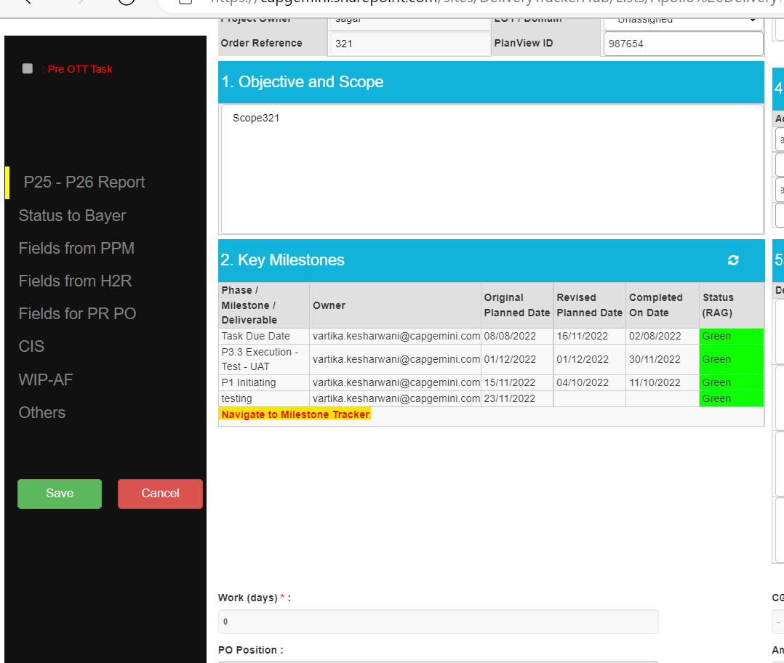

**OR**

* To create the milestones for any OTT, there is one link for each task “**Navigate to Milestone Tracker**” (present in All items, All Column View of Apollo DeliveryTracker List) which on clicking lands on the Milestone Tracker Form.

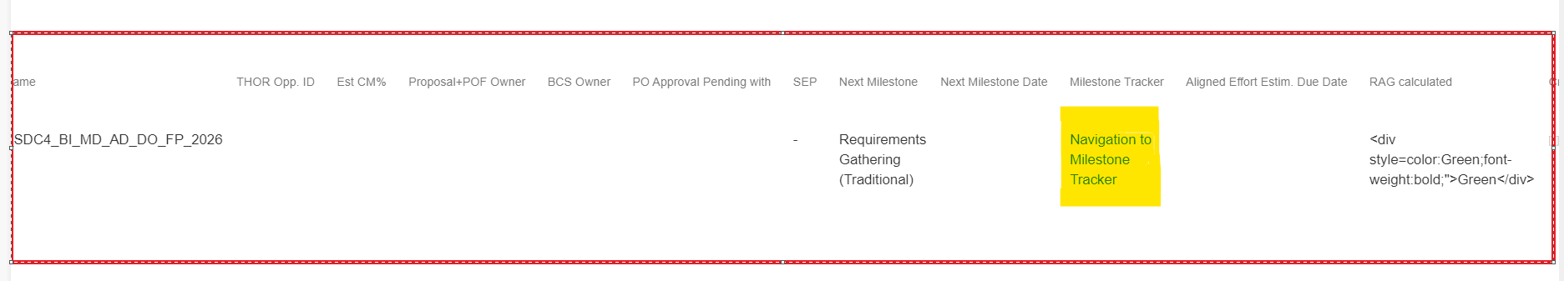

View of Milestone Tracker Form (Task Due Date is the default milestone for every OTT which is SLA in nature and Original Planned Date of this section is filled with the Task Due Date of an OTT)

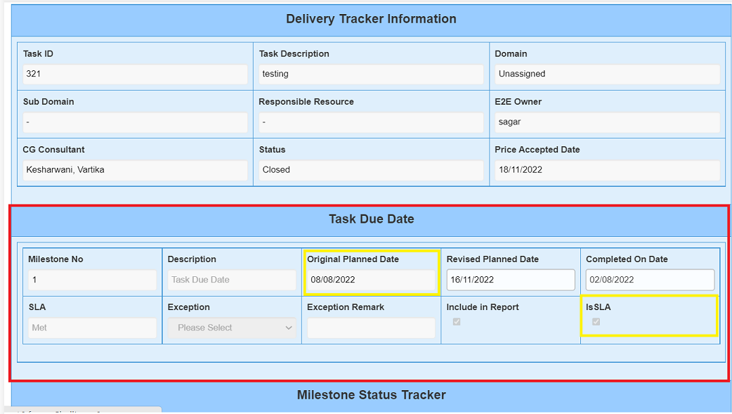

**Step 2.** Once you reach the Milestone Tracker Form, Click on **Add Milestone** Button to add the milestones which is present at the bottom of the form.

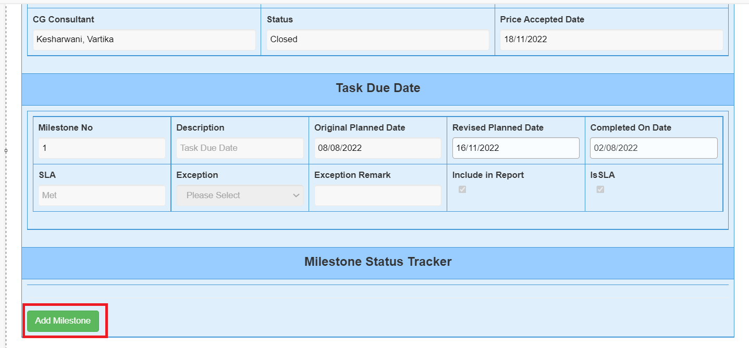

**Step 3.** By default, Milestone Owner field is filled with the *CG Delivery Owner* mail id, change the Milestone Owner Email ID based on type of milestone that needs to be created.

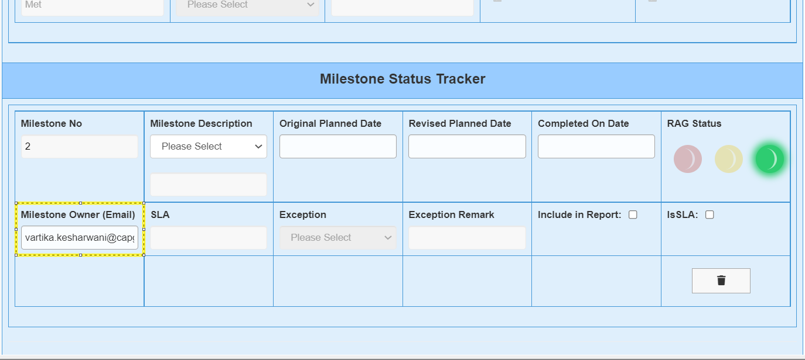

**Step 4.** Fill all the details for each milestone (like Description, Original Planned Date, Completed On Date, RAG Status, Milestone Owner, etc.). Check the field “Include in Report” to show your milestone in the report else uncheck the “Include in Report” checkbox and it won’t appear in the reports. Also, check the field “IsSLA”, by default it will not be selected, if you want to change the nature of milestone to SLA then select the checkbox of IsSLA. Repeat the Steps 2 & 3 for adding “N” number of milestones for your OTT.

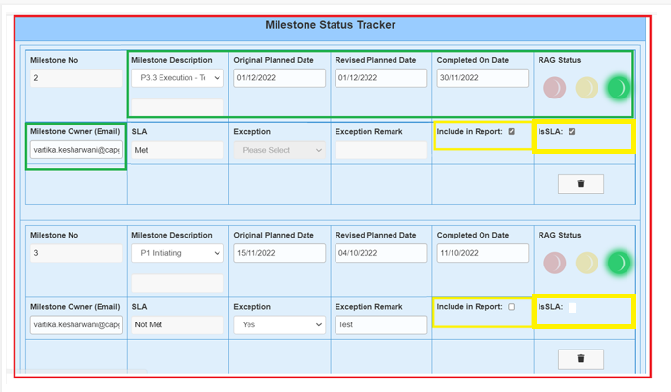

***Step 5.*** Click on Submit button to save your milestones.

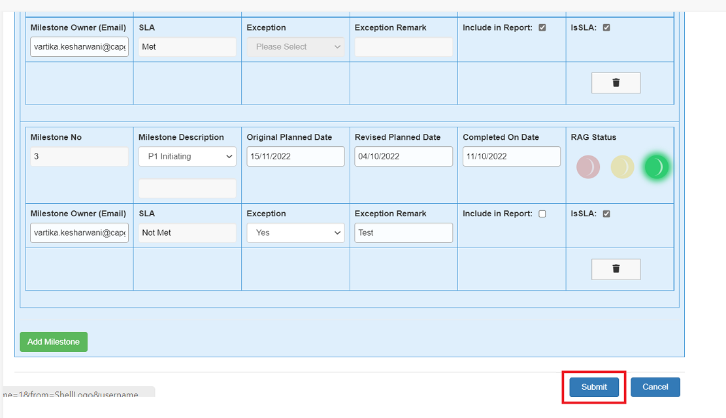

**NOTE**: For Milestone No. 2, the milestone owner will be by default the CG Delivery Owner Email ID and rest succeeding milestones will also have the same Milestone Owner as CG Delivery Owner Email ID. But if you update the Milestone Owner of Milestone No.2 then the succeeding milestones owner will be same as the Milestone No. 2 Owner. So, update your milestone owner accordingly.

## Steps to update milestones

To update any milestones data of your OTT, Open the edit form in Apollo Delivery Tracker and click on “*Navigate to Milestone Tracker*” OR open the “All Items, All *columns” view of Apollo Delivery Tracker List and there is a column called Milestone Tracker* which is having the link “*Navigate to Milestone Tracker*”, click on that link. Once the Milestone Tracker form is opened, update your milestones data (Description, revised Planned Date, Milestone Owner, Completed On Date, RAG Status, etc.) and click on **Submit** button to save your updated milestones data. Now, the updated milestone will appear in the edit form, display form and reports.

If any milestone is wrongly created, then click on the delete button associated with each OTT. Follow the below screenshots to delete the milestone.

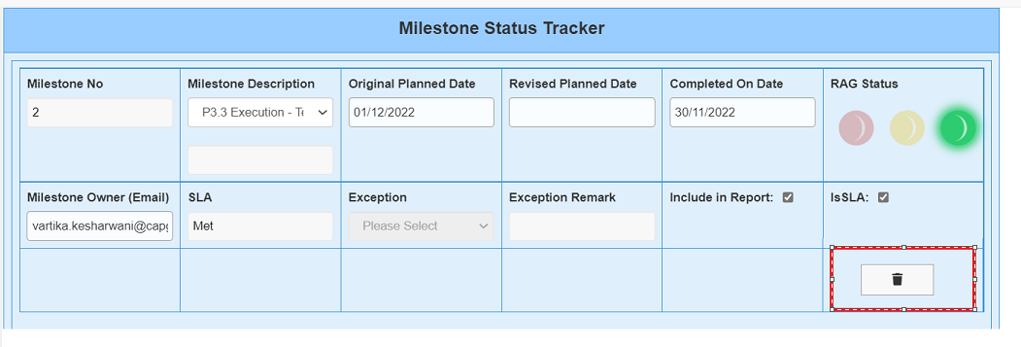

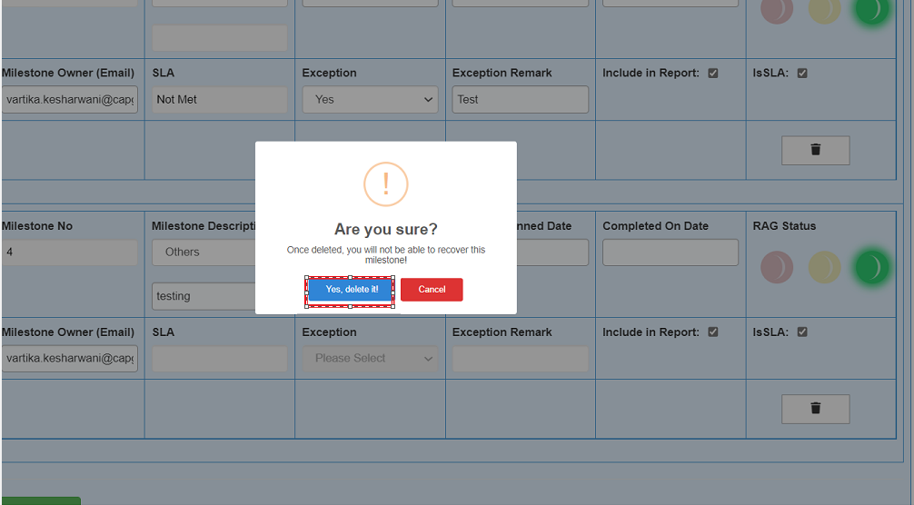

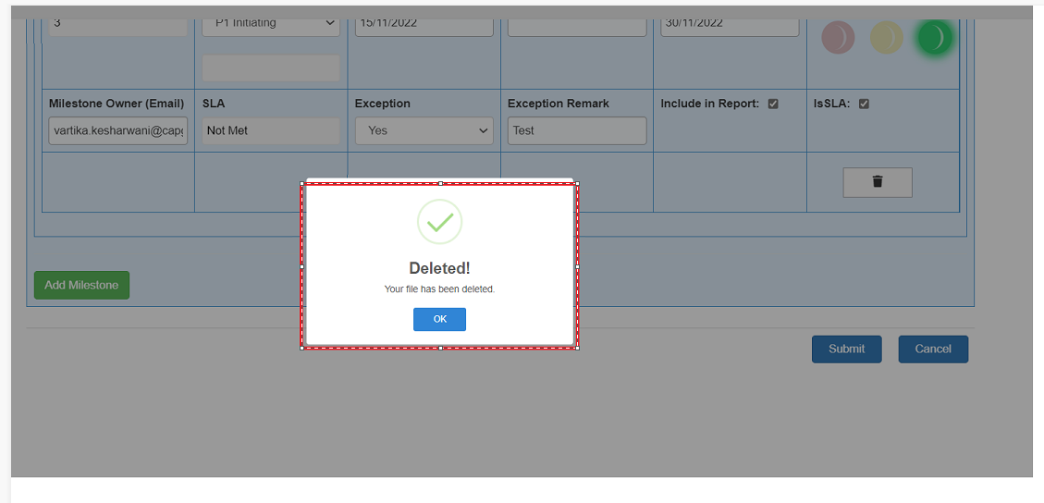

Once you receive this above notification, click on **Submit** button so that your deleted milestone will also be deleted from the milestone tracker list else the deleted milestone will still be available for the OTT.

## Steps to Monitor milestones

To monitor your milestones i.e., SLA and Non-SLA milestones, open the Milestone Tracker Form and check the milestones data and manage it accordingly. You can also monitor your milestones from the “Edit Form” and “Display Form” of the list Apollo Delivery Tracker.

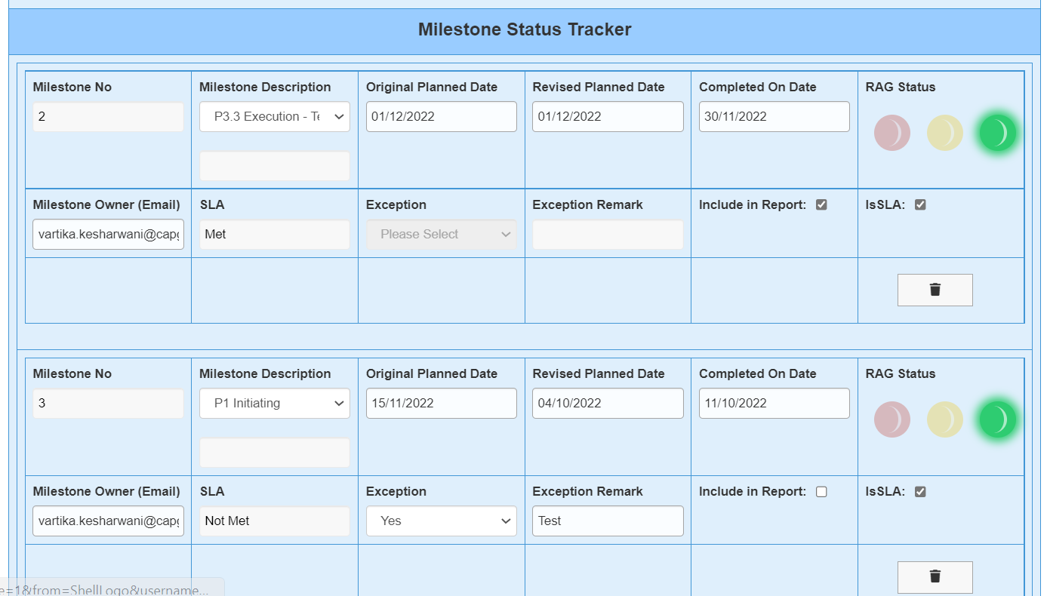

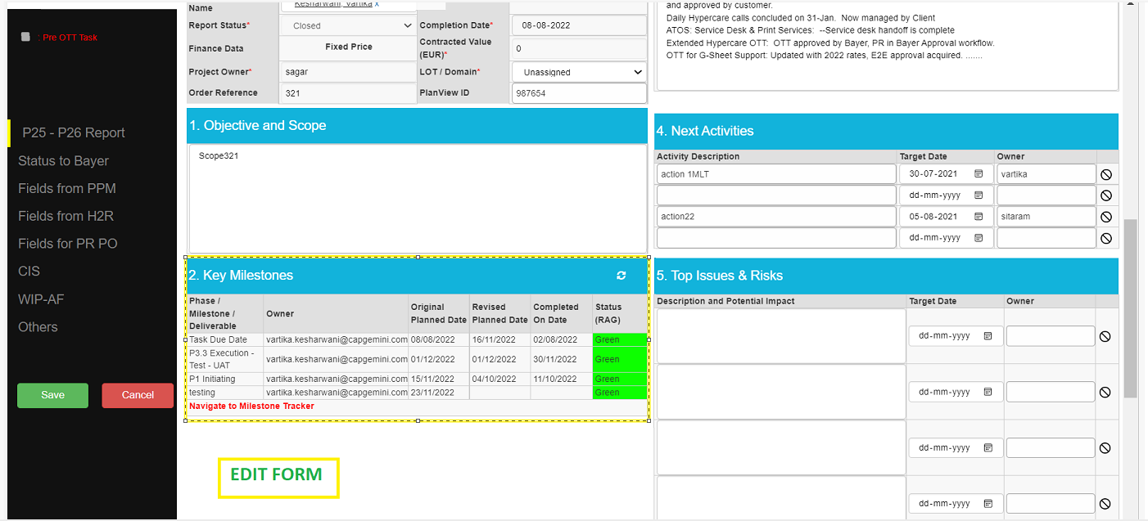

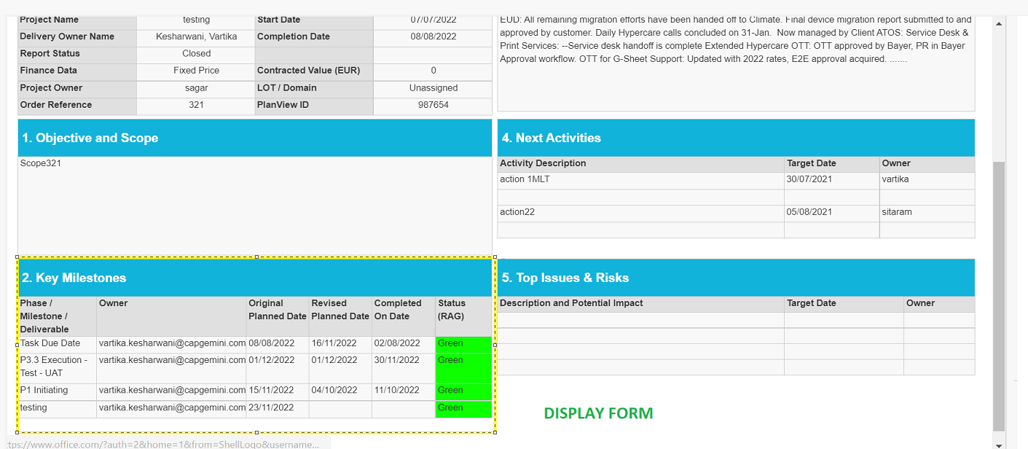

## Validations in Milestone Tracker form*.*

* **Milestone Description**, **Original Planned Date** and **Milestone Owner** are mandatory fields. If you try to submit the form with any of this above column as empty, it will not save the milestones of the OTT and throw the validation error.

In case Milestone Description is empty*.*

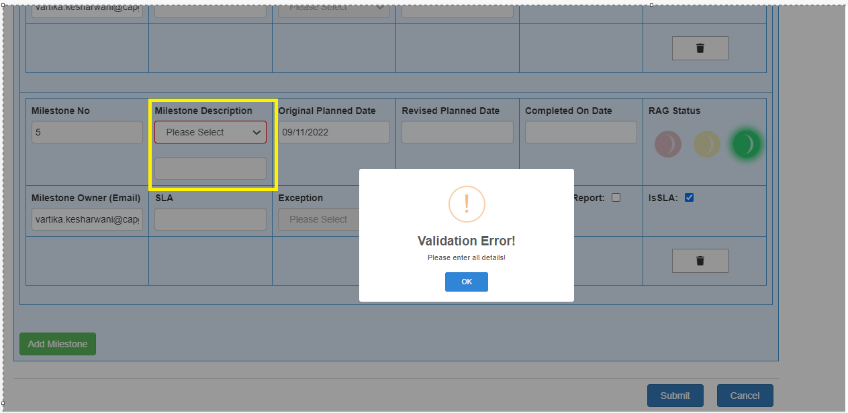

In case Original Planned Date is empty

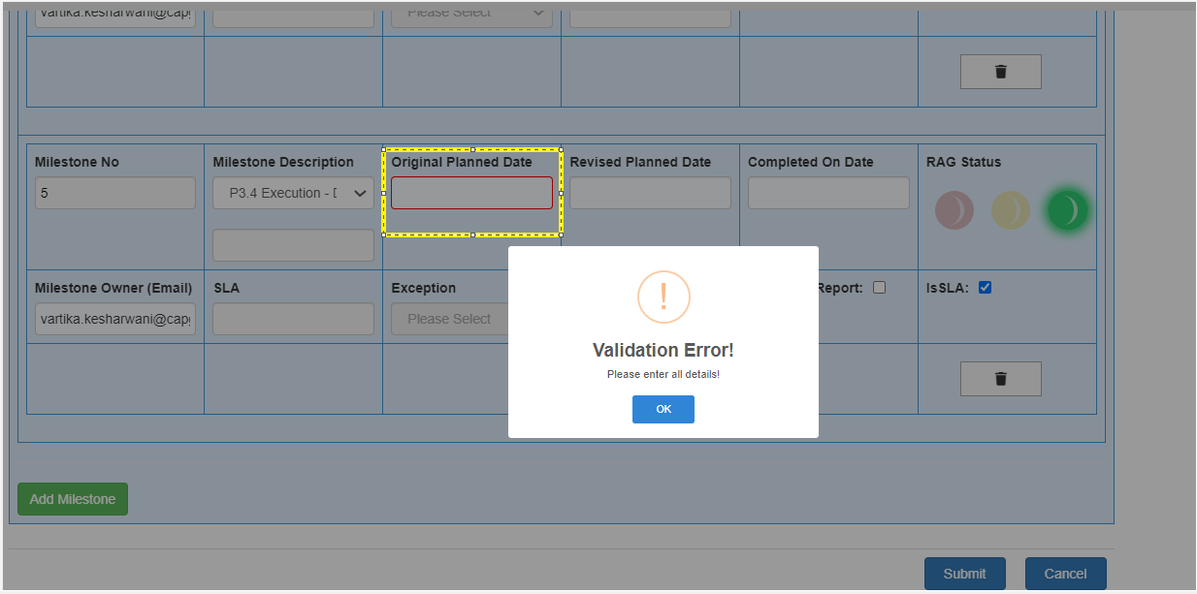

In case Milestone Owner is empty

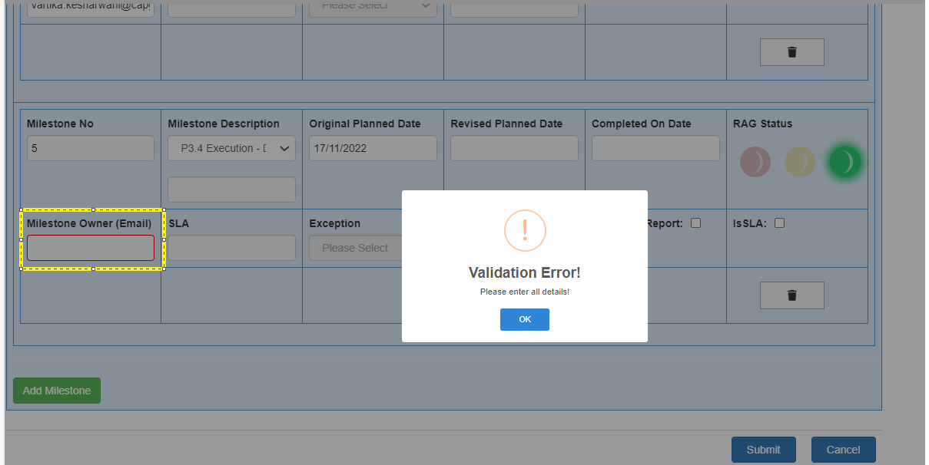

In case all mandatory fields are empty

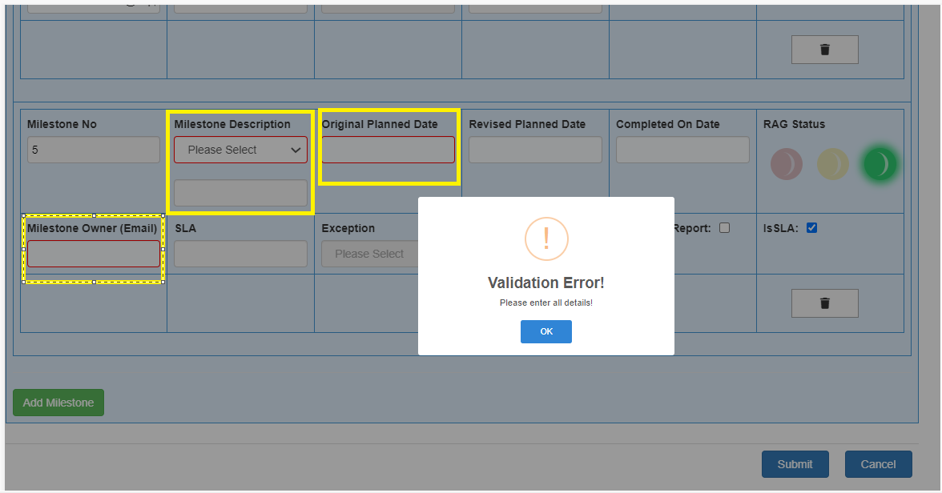

On the above scenarios, click on **OK** and fill all the mandatory details and click on **Submit** button to save the milestone data in the tracker.

**NOTE:** The milestone Owner column should have a proper format of Company Name mail id else it will throw the validation error (applicable if SLA checkbox checked)

1. Milestone Description is a choice field select the milestone Description from the dropdown else select “Others” option and fill your **custom** milestone description in the below box.

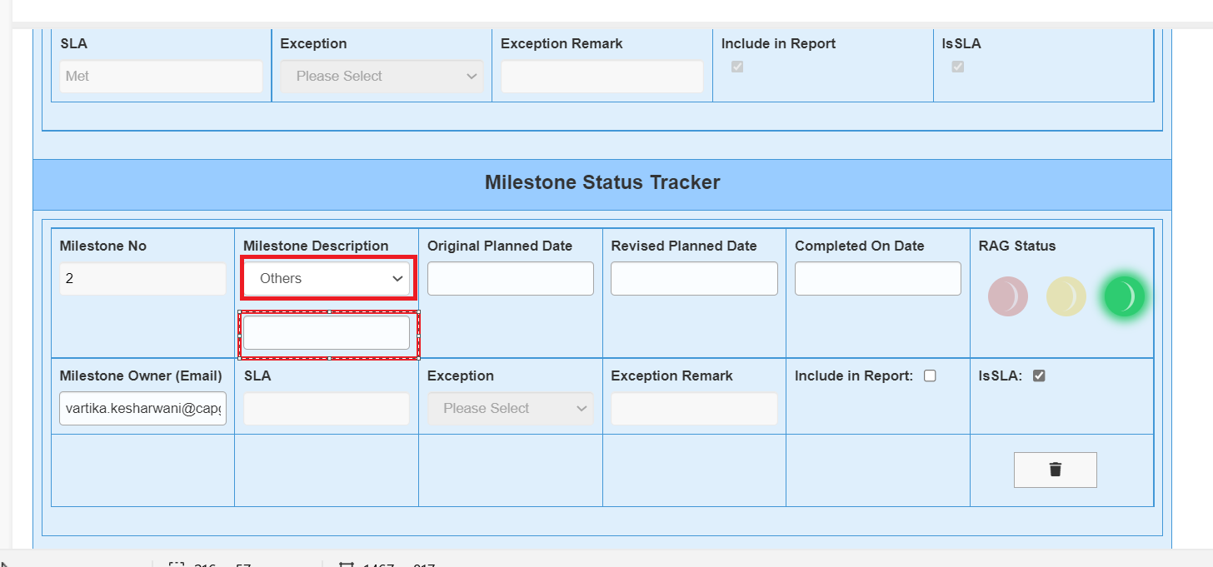

1. Automatic Calculation of SLA (only applicable if IsSLA is checked)

* **Revised Planned Date is filled**

1. If (Completed on Date > Revised Planned Date), then **SLA value** shows NOT Met and it is mandatory to fill the column “Exception” and “Exception Remark” and they will be enabled.

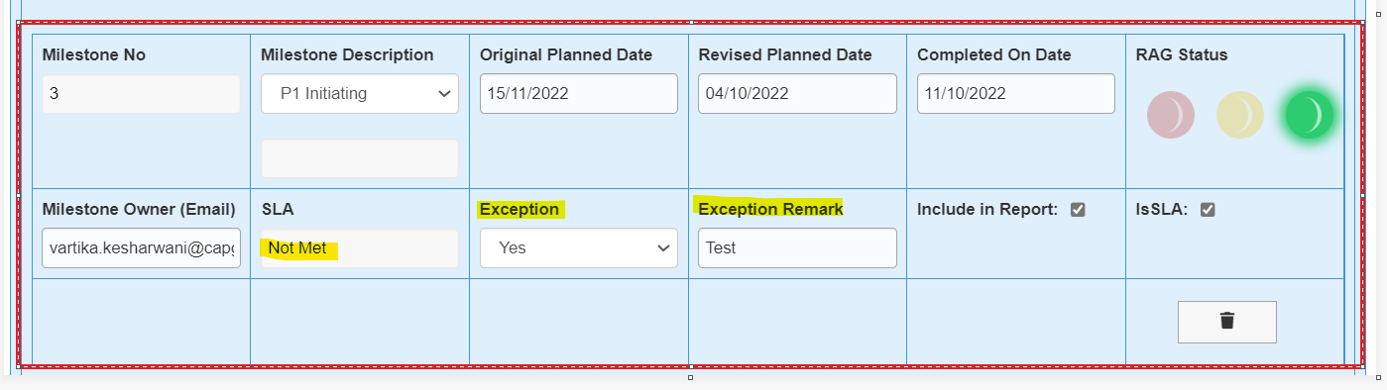

1. If (Completed On Date < Revised Planned Date), then **SLA value** shows Met and it is NOT mandatory to fill the columns “Exception” and “Exception Remark” and they will be disabled*.*

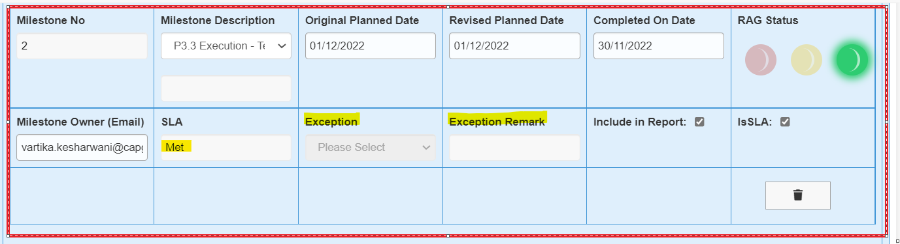

* **Revised Planned Date is empty, in this case we consider the Original Planned Date**

1. If (Completed On Date < Original Planned Date), then **SLA value** shows **Met** and it is NOT mandatory to fill the column “Exception” and “Exception Remark” and they will be disabled.

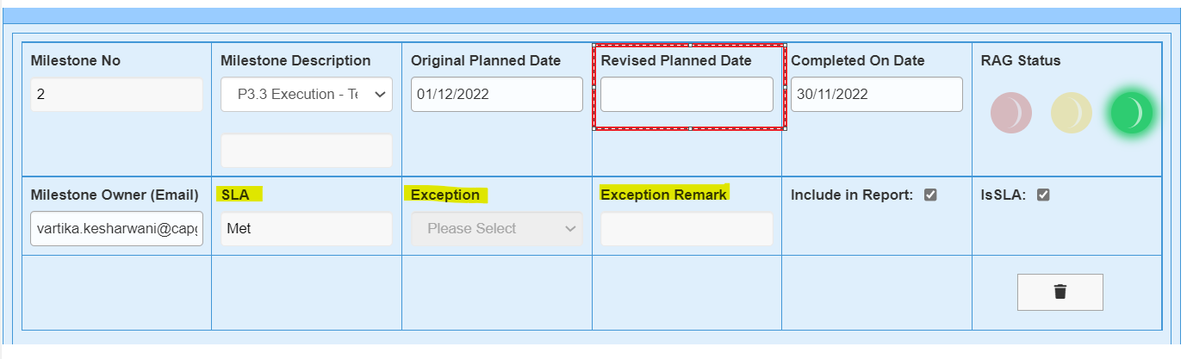

1. If (Completed On Date > Original Planned Date), then **SLA value** shows **Not Met** and columns “Exception” and “Exception Remark” are mandatory to fill and they will be enabled.

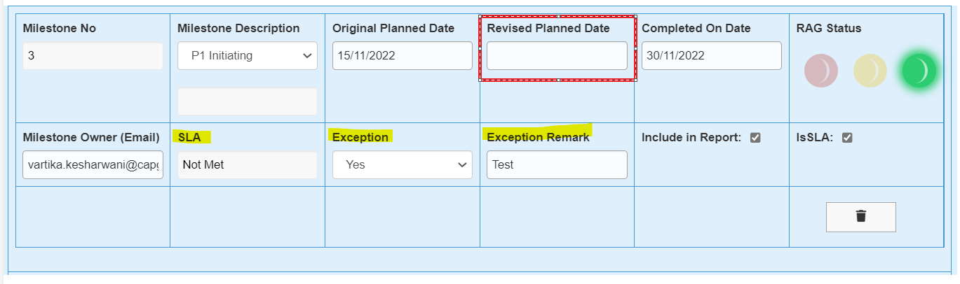

## % Complete Calculation

We have introduced two sections for calculating the **% complete** of milestones.

1. Automated % Complete
2. Manual % Complete

Above columns are visible in Edit form of Apollo Delivery Tracker List OTTs.

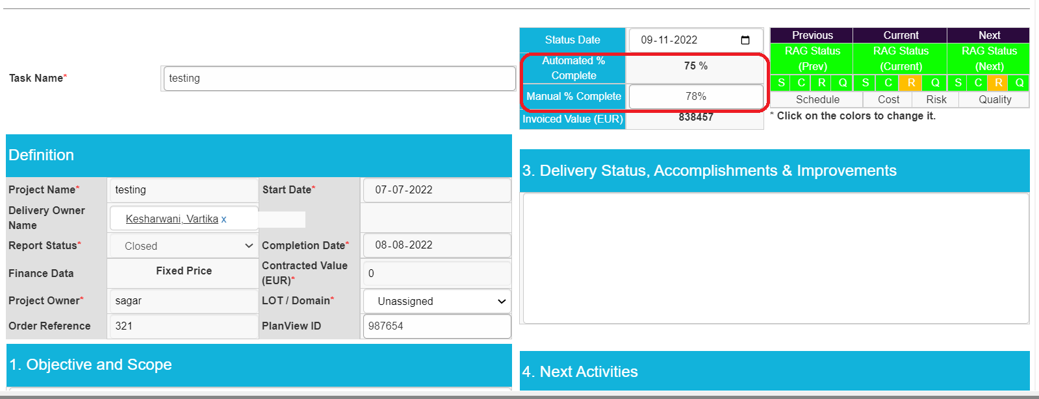

**Calculation**

***Automated % Complete***: This is an automate calculated column which calculates based on the below formula.

*Automated % Complete = Total no. of Completed On Dates Present / Total No. of Milestones*

**Manual % Complete:** This column is maintained by the user manually based on their milestone completion.

But, In the Display Form of Apollo Delivery Tracker list of OTTs and in Reports, we showcase only a single % complete for the milestones.

**Criteria*:***

**Case 1:** If “Manual % Complete” is empty, then Automated % Complete is considered for the % Complete column in Display Form as well as in Reports.

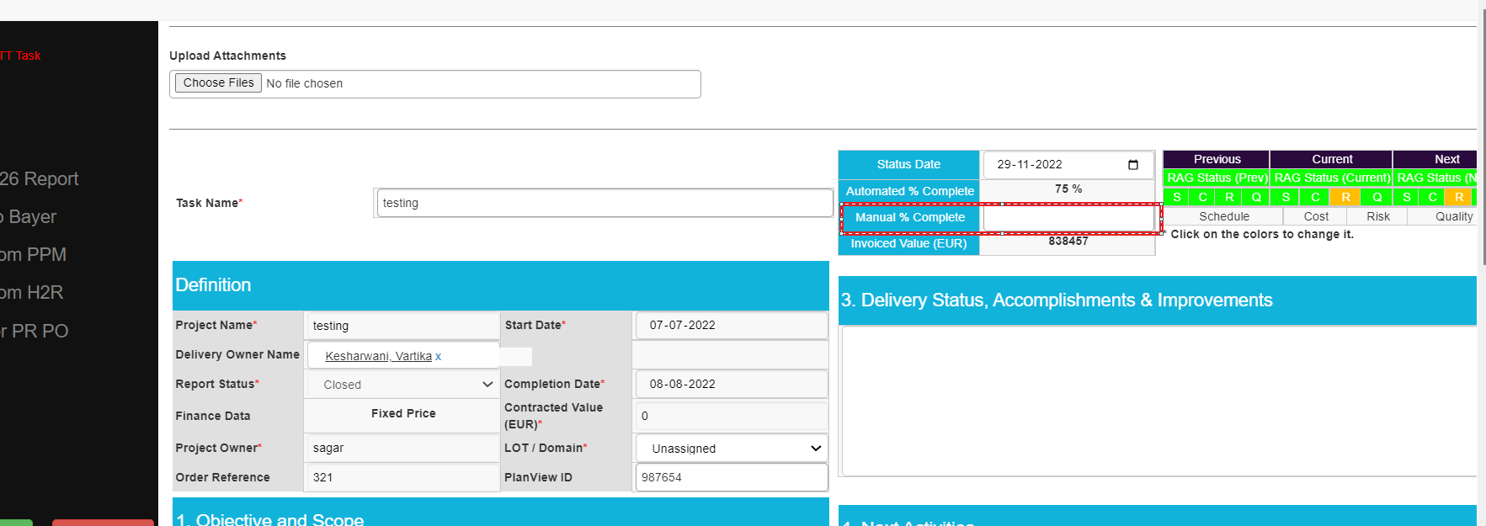

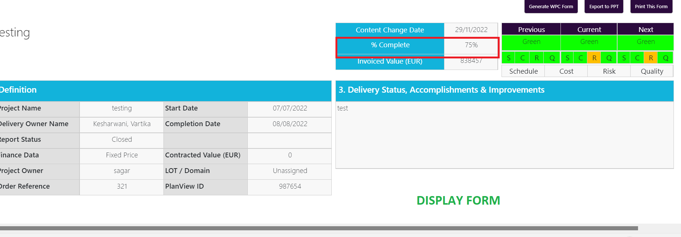

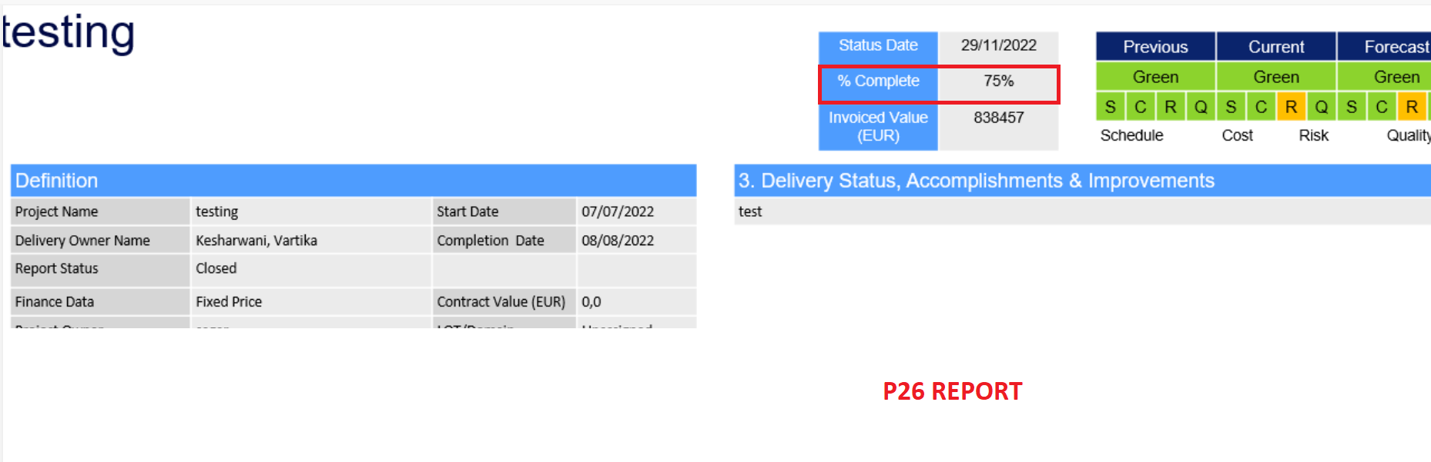

**Case 2:** If “Manual % Complete” is filled, then Manual % Complete is considered for the % Complete Column in Display Form as well as in Reports.

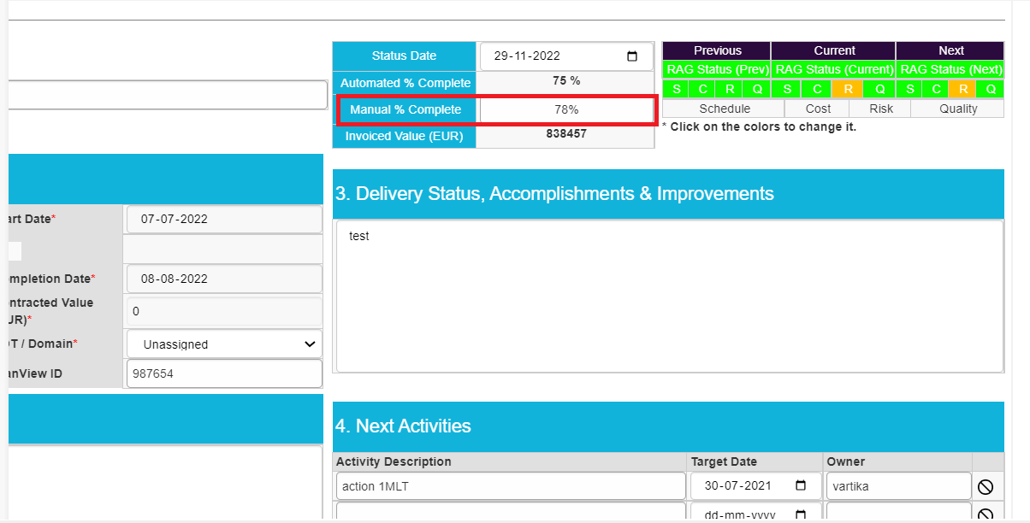

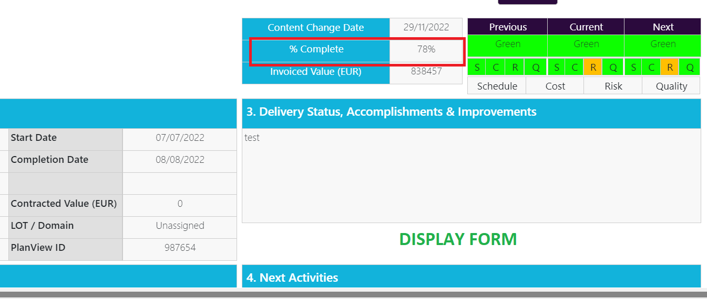

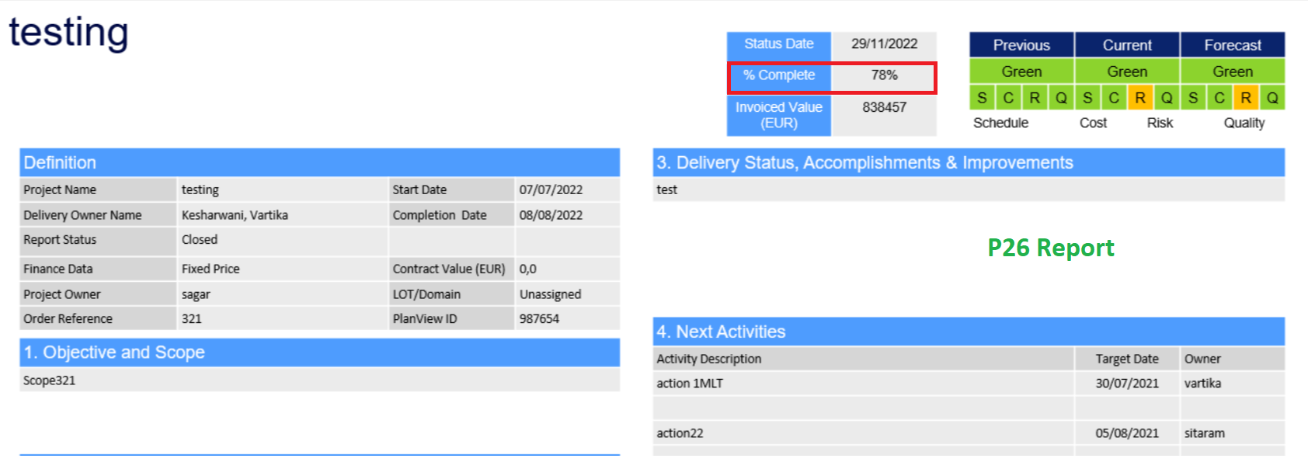

**NOTE:** In reports we are considering only those milestones which are selected as “**Include in Report”** in milestone tracker formand based on the no. of milestones present in the reports, the automated % complete is calculated.